Delux Solutions Implementation Manual

How To Install And Setup WP Mail SMTP

PROVIDED BY:
Your Solutions Partner

DISCLAIMER AND DISTRIBUTION STATEMENT:
This document is provided as is and does not provide any solutions or fixes to your systems.
Distribution of this document is limited to our staff and customers on a need-to-know basis. Any other distribution is strictly prohibited.

Table Of Revisions
DATE | Revision # | Revision Description | Revised By:
12/16/22 | 1.0 | Initial Document Creation | Mark R. Wood
Contents
1.0 Purpose and Scope 8
2.0 General Information 8
3.0 Responsibilities 8
3.1 Review / Update 8
3.2 Precedence 8
4.0 Assumptions 8
5.0 Installing The Plugin 9
6.0 Configuring The Plugin 11

Purpose and Scope
This document establishes the processes and procedures for installing and setting up the WP Mail SMTP plugin on a WordPress site.

2.0 General Information
Standardized procedures are necessary to ensure consistent operation. They also provide a path of instruction for persons completing tasks for which they may be unfamiliar in doing.

3.0 Responsibilities
All Delux Solutions IT Department staff are responsible for maintaining / creating a complete set of How To and Procedural documents for all tasks they perform or can be performed by other staff members or customers.
Those documents are then uploaded to the proper SharePoint Library and also to our public facing website based on the need-to-know.

3.1 Review / Update
All documents will be reviewed on a quarterly basis and updated as required in order to provide as much detail as possible on how to perform a specified task. The IT Department will make every effort to continuously keep these documents up to date.

3.2 Precedence
In the event that any procedure in this document is found to be in conflict with other documents then both documents must be updated to reflect the most current procedures.

4.0 Assumptions
- You have your own web server with IIS installed
- You have basic knowledge on how to perform WordPress tasks

5.0 Installing The Plugin

- On the left menu go to Plugins and then click on Add New
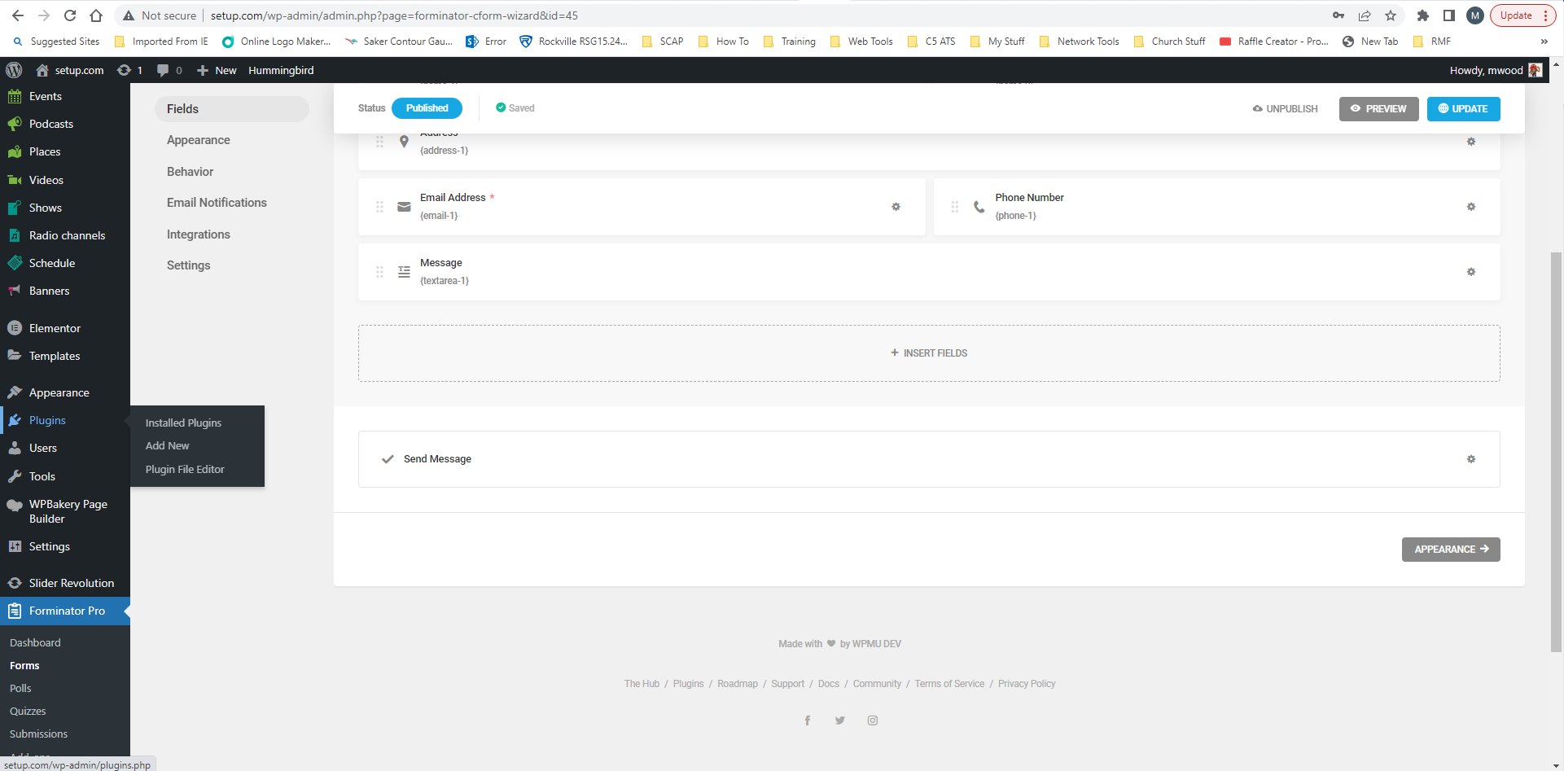

- In the search box, next to Keyword, type in WP Mail SMTP and when it appears on the screen click Install Now
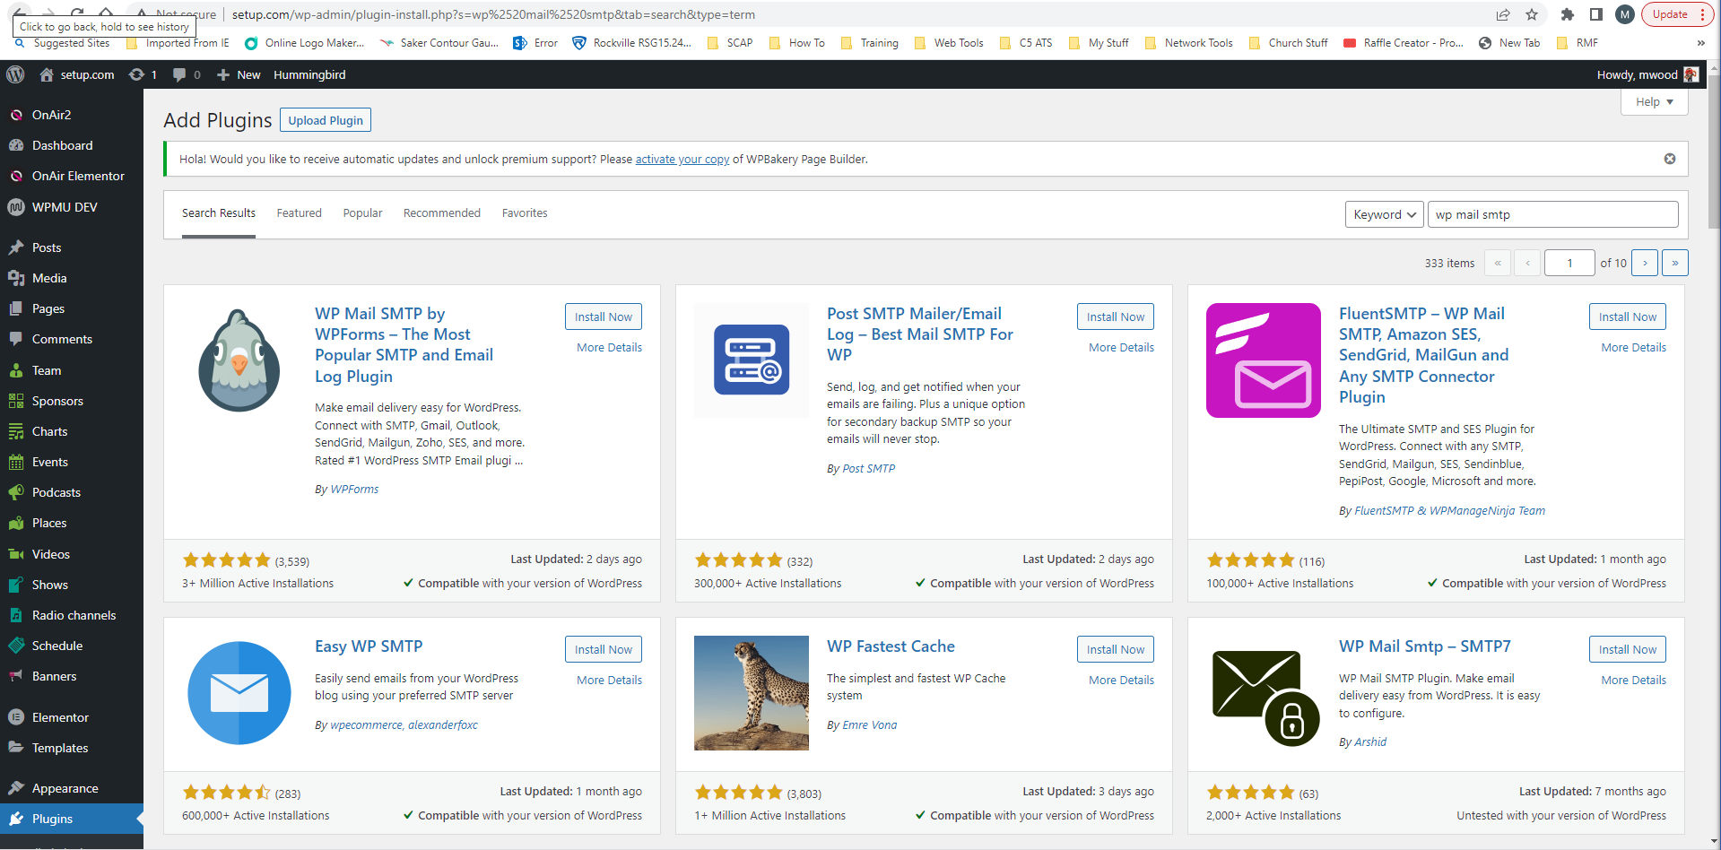
- The plugin will begin installing
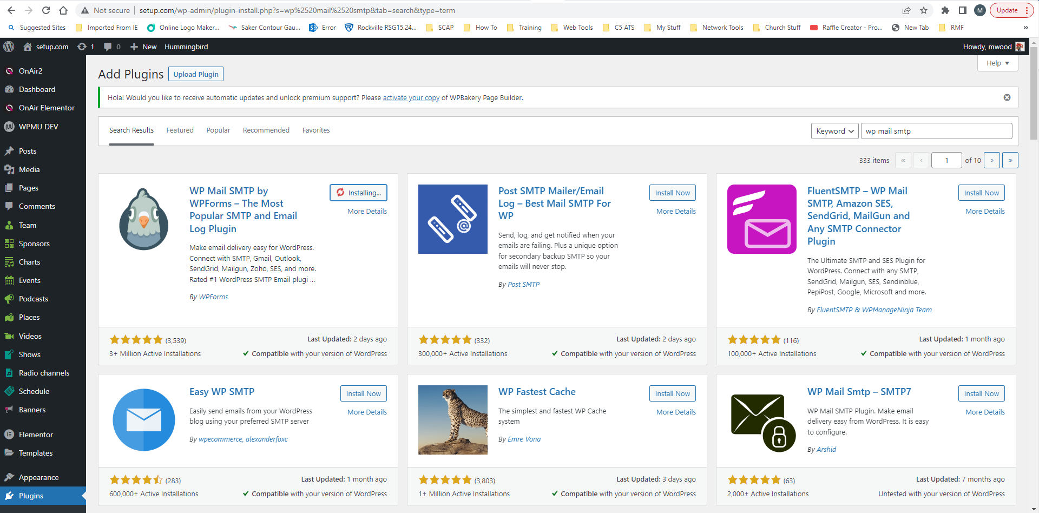

- When it is finished click Activate
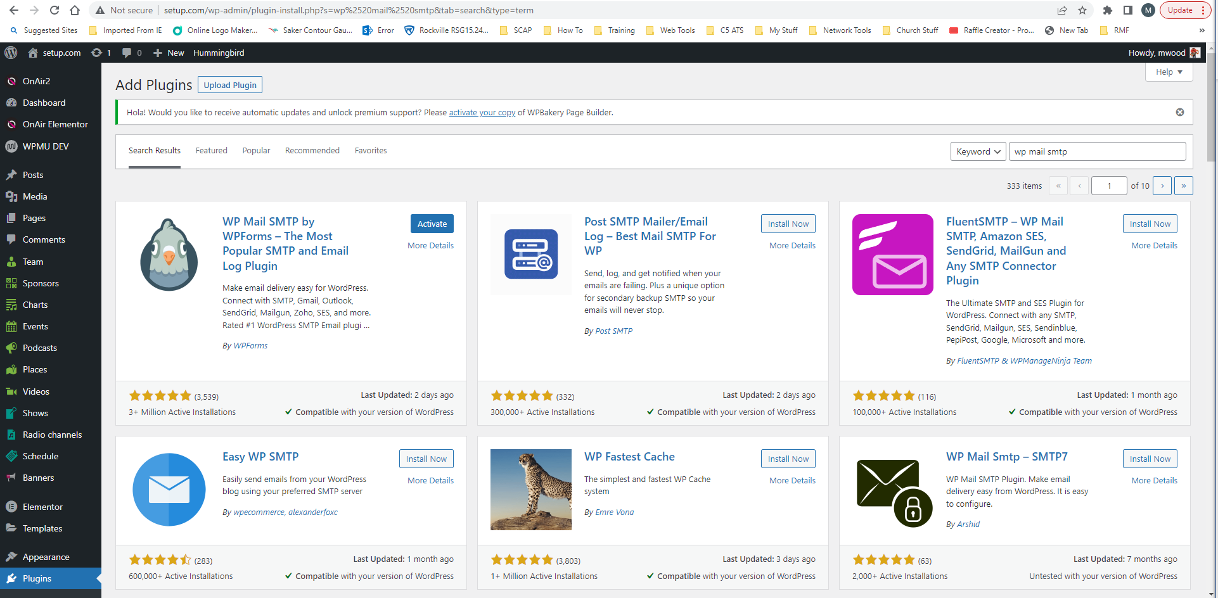

6.0 Configuring The Plugin

- After the plugin has successfully activated it will take you to the setup wizard. Click on Let’s Get Started
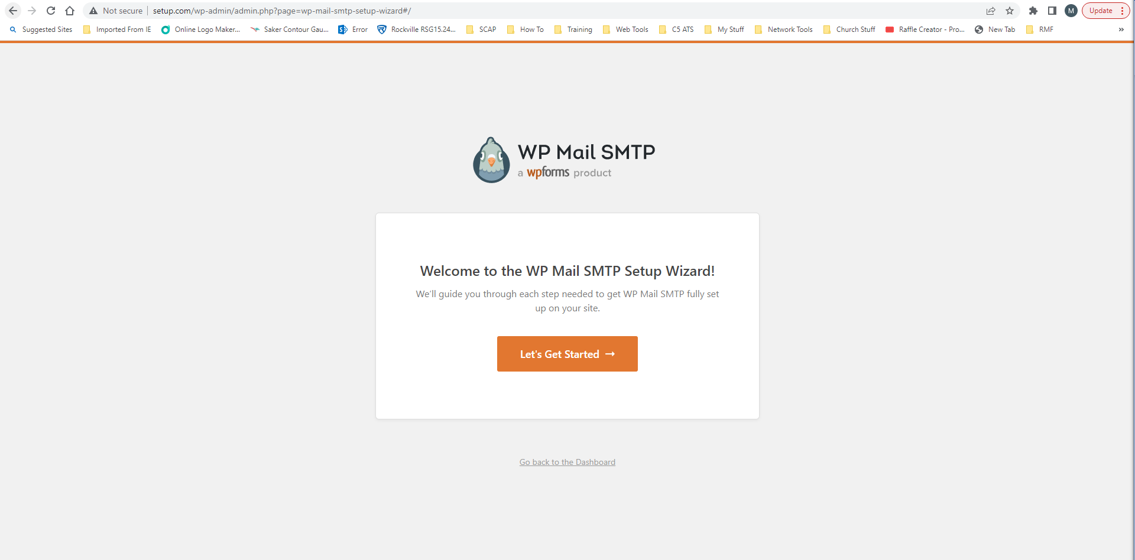

- When the following page opens click on Other SMTP then click Save and Continue
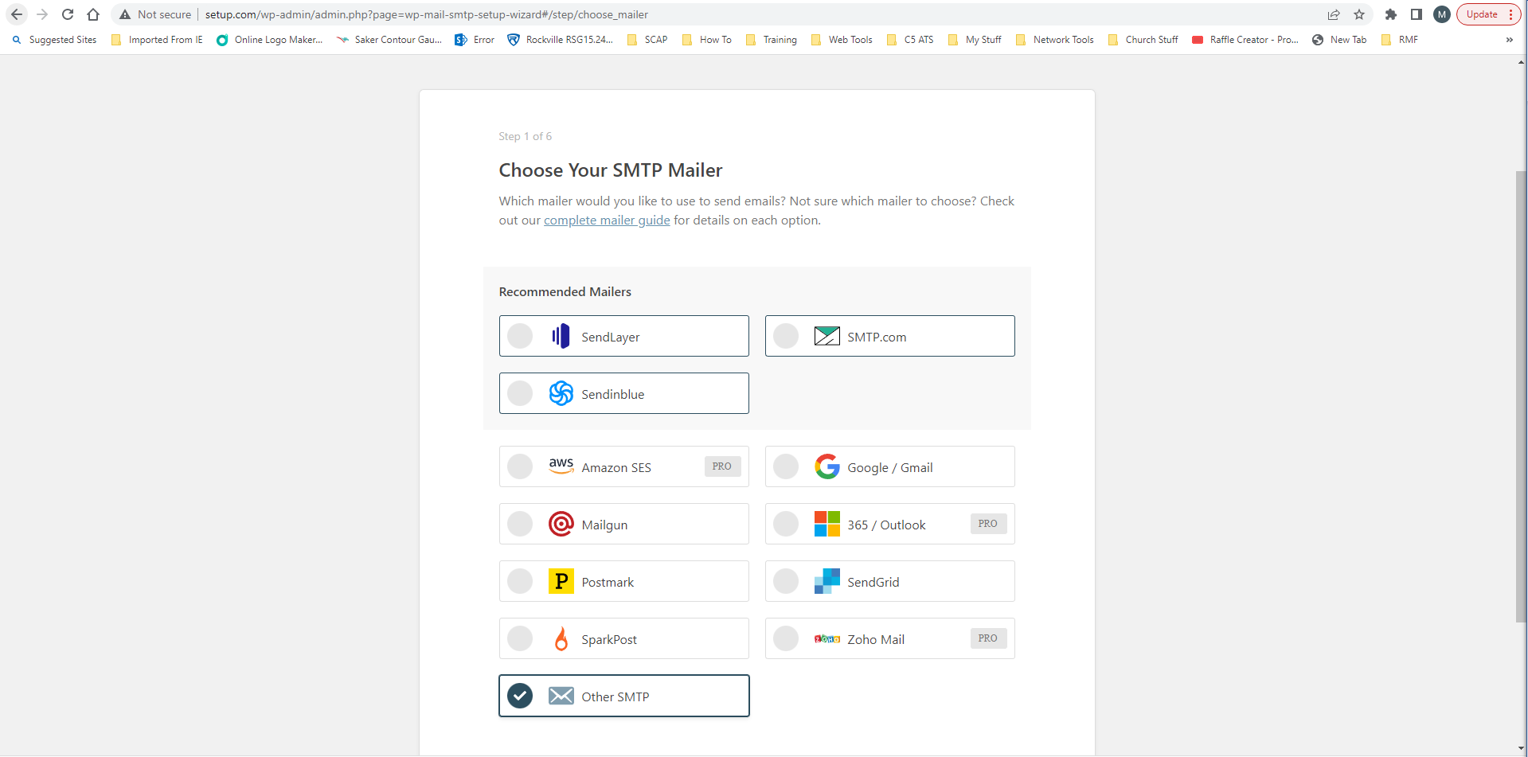
- On the Configure Mailer Settings page enter the IP address of your mail server in the SMTP Host box, Set Encryption to None, and leave Auto TLS on
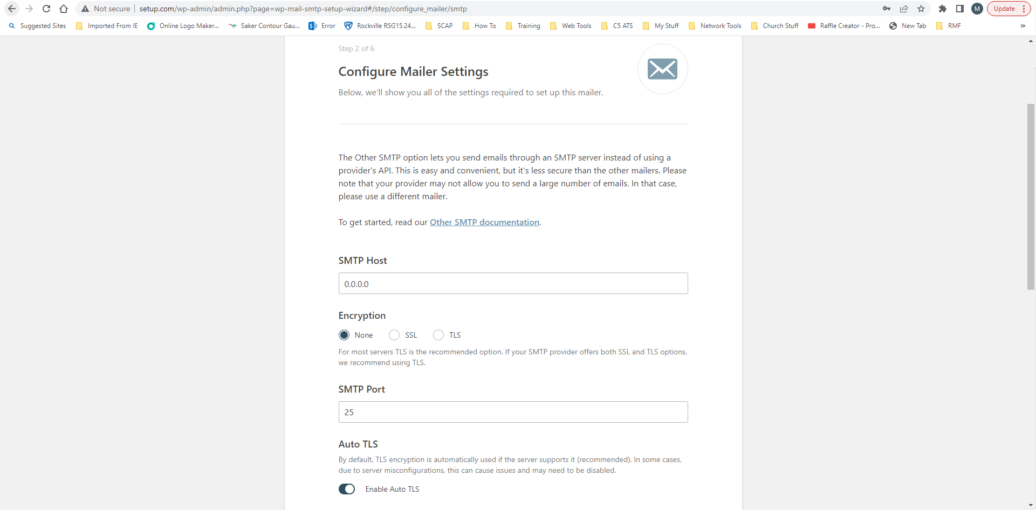

- Scroll down the same page and turn on Authentication and if you setup MailEnable correctly you will use no-reply@yourdoamin and the password. You will also turn on Force From Name and in the From Email enter no-reply@yourdoamin. Then scroll down a little and click on Save and Continue
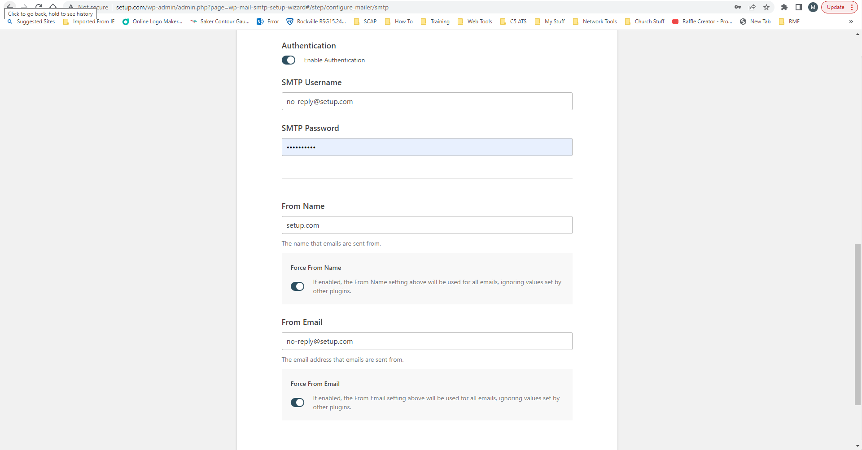
- Click on Save and Continue again
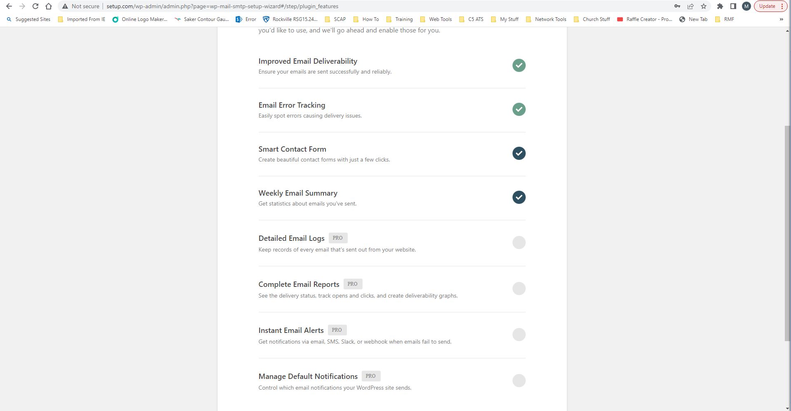

- Now click on Skip this Step
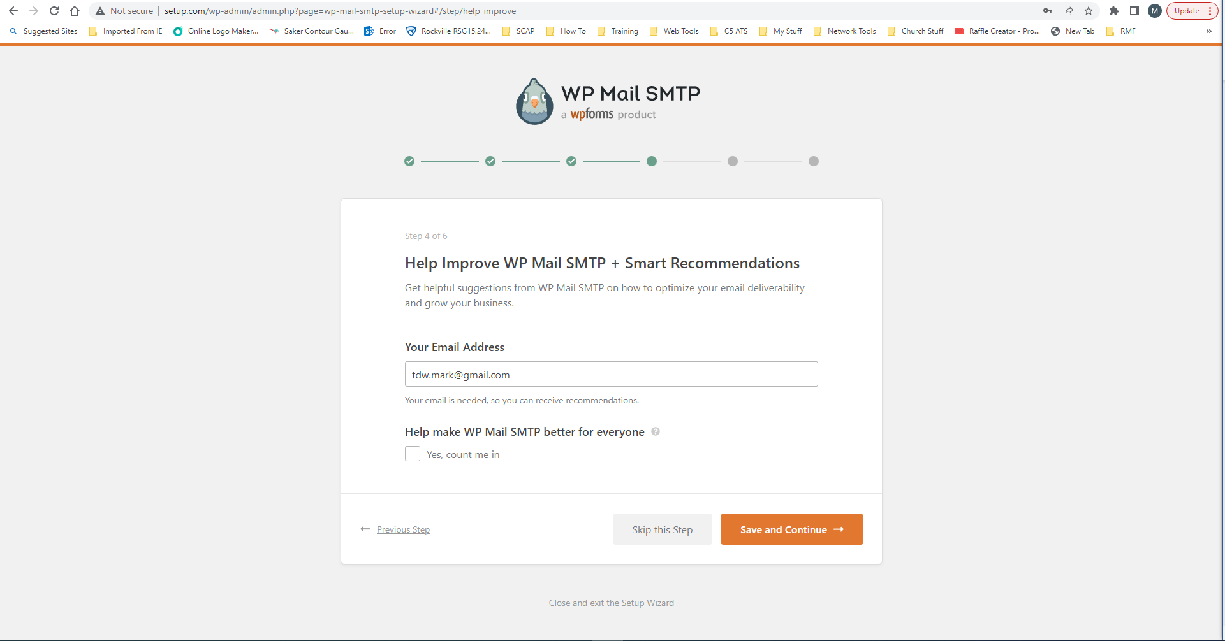
- Click on Skip this Step again
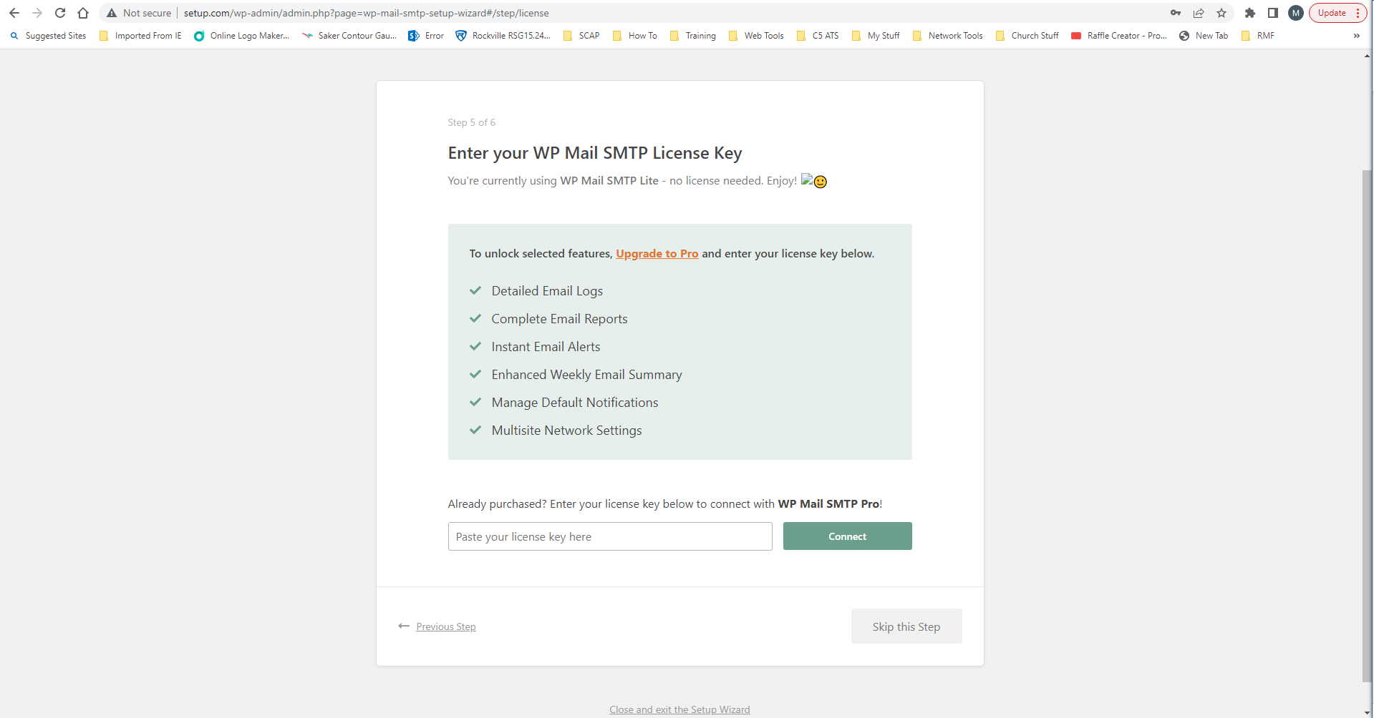

- If you did everything correctly you should have gotten a test email from the site sent to the admin email.

