Delux Solutions Implementation Manual

How To Administer A DS WebMail Post Office

PROVIDED BY:
Your Solutions Partner

DISCLAIMER AND DISTRIBUTION STATEMENT:
This document is provided as is and does not provide any solutions or fixes to your systems.
Distribution of this document is limited to our staff and customers on a need-to-know basis. Any other distribution is strictly prohibited.

Table Of Revisions
DATE | Revision # | Revision Description | Revised By:
12/21/22 | 1.0 | Initial Document Creation | Mark R. Wood
Contents
1.0 Purpose and Scope 8
2.0 General Information 8
3.0 Responsibilities 8
3.1 Review / Update 8
3.2 Precedence 8
4.0 Assumptions 8
5.0 Accessing The Post Office 9
6.0 Settings 10
6.1 Mailboxes 10
6.1.1 Modifying An Existing Mailbox 11
6.1.2 Creating A New Mailbox 13
6.2 Groups 16
6.2.1 Creating A New Distribution Group 16
6.2.2 Modifying A Distribution Group 18
6.3 Lists 21
6.3.1 Creating A New List 21
6.3.2 Modifying A List 26
6.3.3 List Commands 29
6.4 Domains 29
6.4.1 Creating A New Domain 30
6.4.2 Modifying A Domain 31
6.5 DKIM 32
6.5.1 Modifying A DKIM Record 32

Purpose and Scope
This document establishes the processes and procedures for administering a MailEnable Post Office.

2.0 General Information
Standardized procedures are necessary to ensure consistent operation. They also provide a path of instruction for persons completing tasks for which they may be unfamiliar in doing.

3.0 Responsibilities
All Delux Solutions IT Department staff are responsible for maintaining / creating a complete set of How To and Procedural documents for all tasks they perform or can be performed by other staff members or customers.
Those documents are then uploaded to the proper SharePoint Library and also to our public facing website based on the need-to-know.

3.1 Review / Update
All documents will be reviewed on a quarterly basis and updated as required in order to provide as much detail as possible on how to perform a specified task. The IT Department will make every effort to continuously keep these documents up to date.

3.2 Precedence
In the event that any procedure in this document is found to be in conflict with other documents then both documents must be updated to reflect the most current procedures.

4.0 Assumptions
- You have your own MailEnable Email server installed
- You have basic knowledge on how to perform server tasks

5.0 Accessing The Post Office

- Open a web browser and go to https://mailadmin.deluxsolutions.net
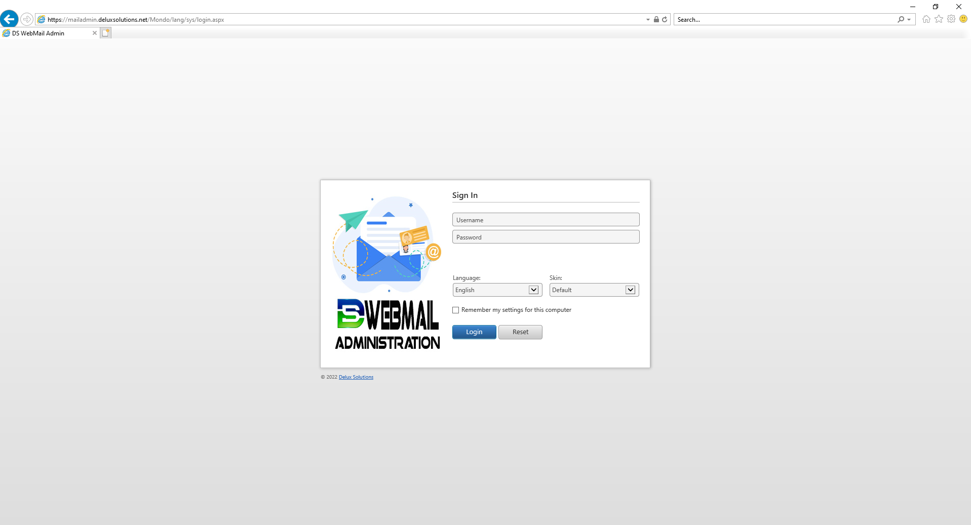

- For the username enter postmaster@yourdomain.suffix. Then enter the password and click Login
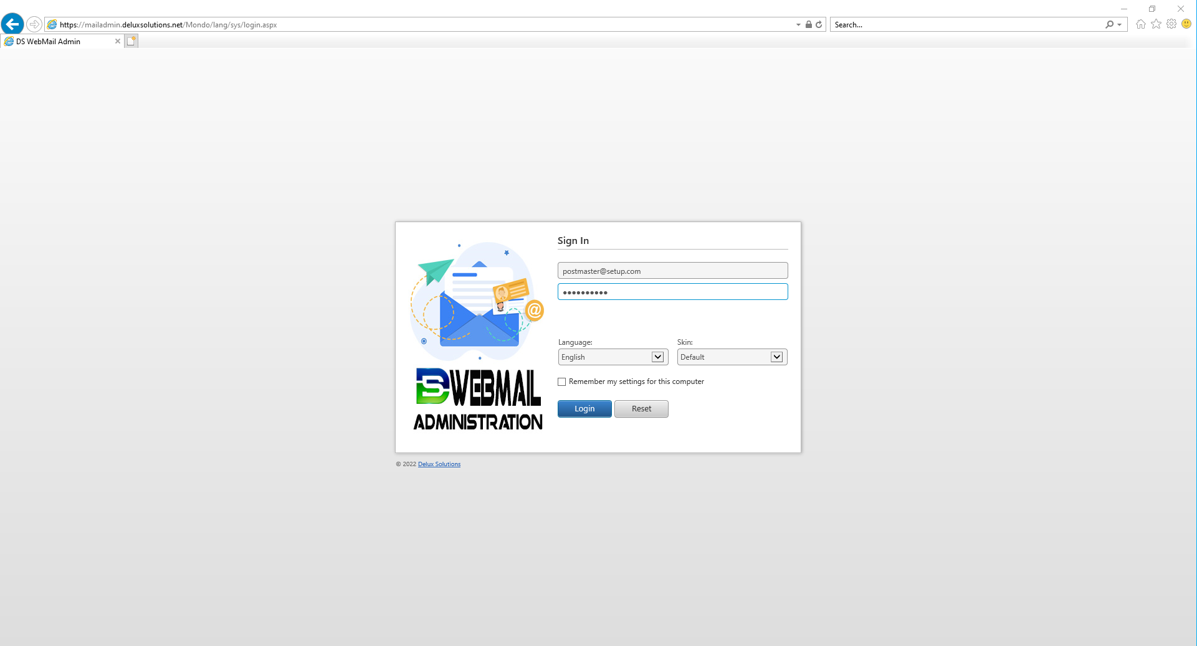
- You should now be here
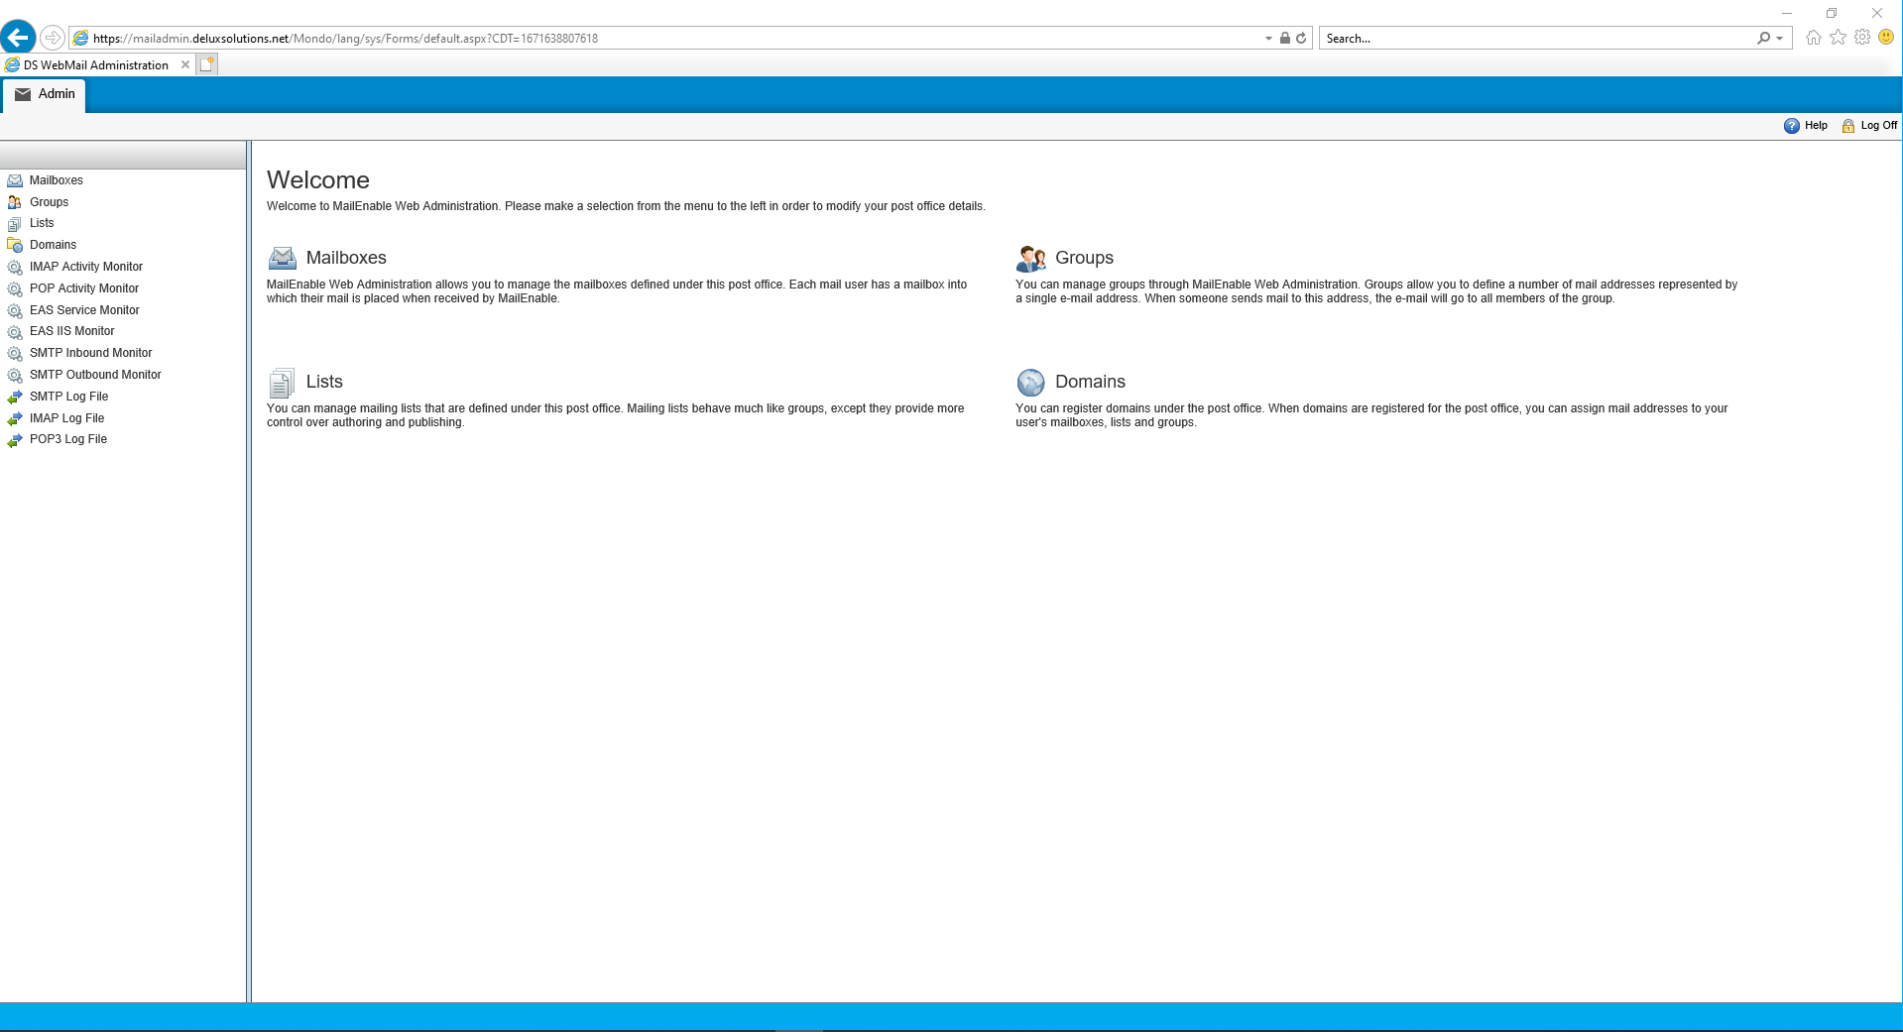

6.0 Settings

6.1 Mailboxes
When a user connects with a mail client application (Outlook Express, Eudora, etc.), they connect to a mailbox to retrieve their email.
- In the menu on the left click on Mailboxes and you will see a list of the current mailboxes you have
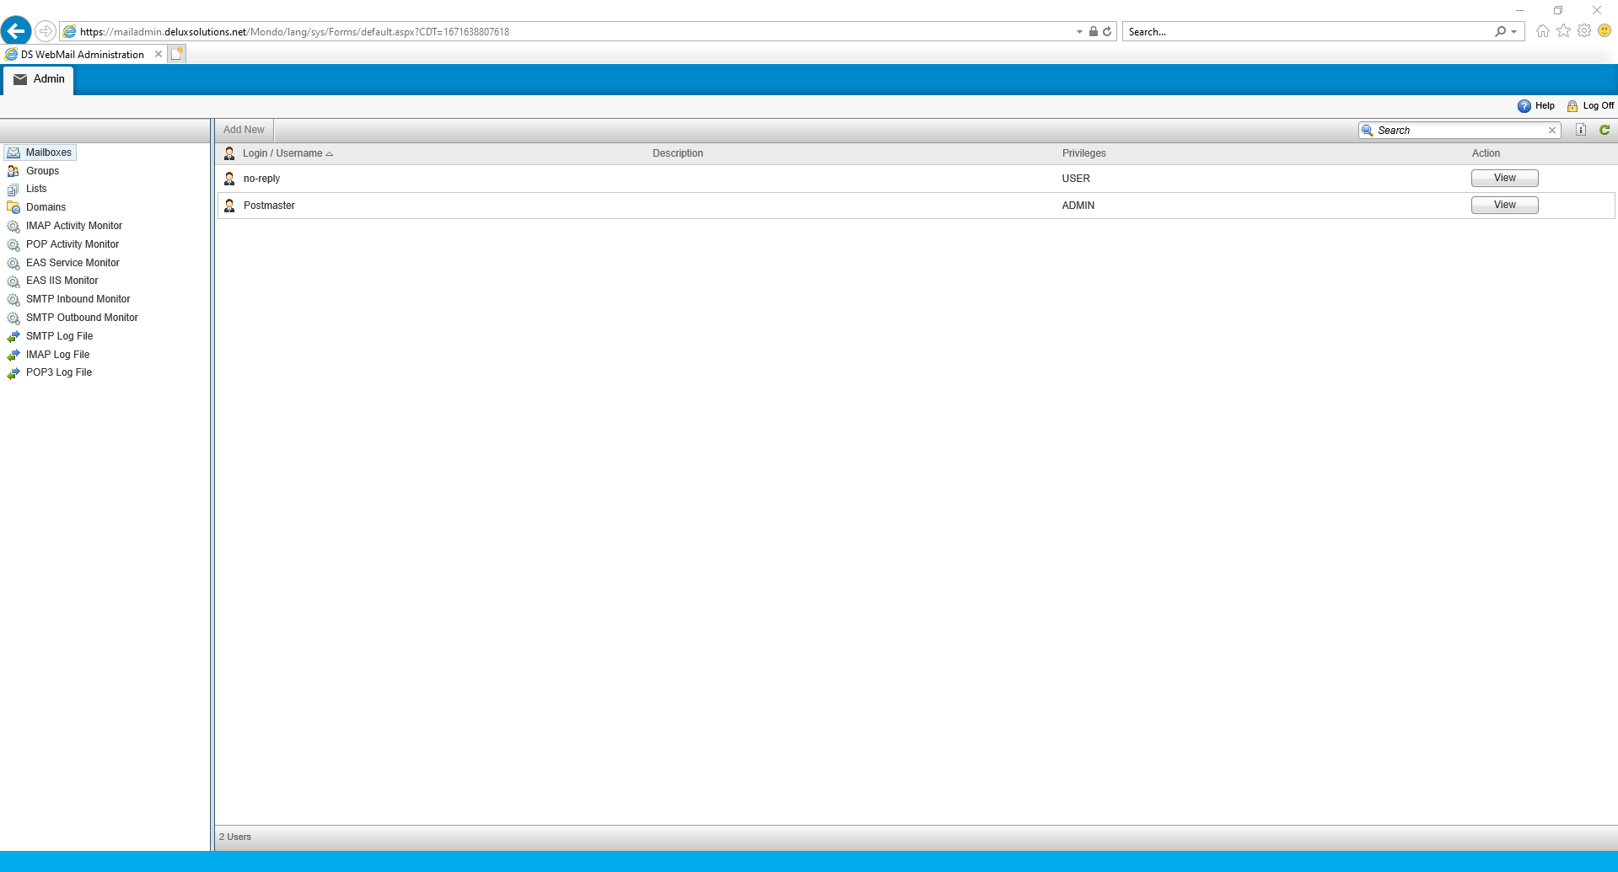

6.1.1 Modifying An Existing Mailbox

- On the far right of an existing mailbox click on Edit. This opens the mailbox to the Login tab where you can change the password, add a display name, select the users rights, force a password change at next login, and disable/enable the account.
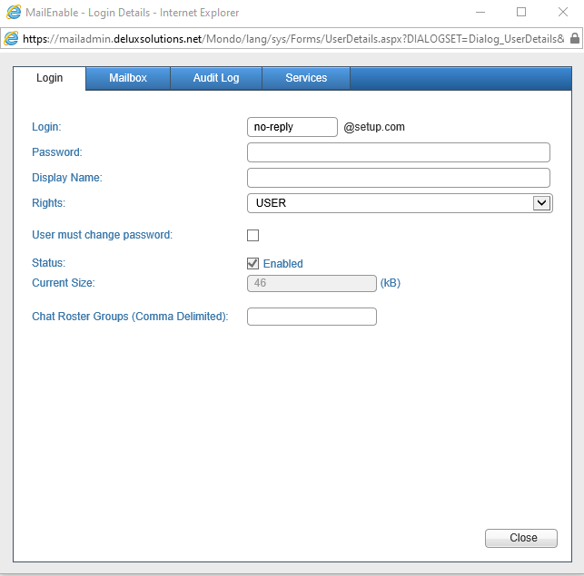

- Click on the Mailbox tab and you can set size limits, redirect all email to a different account, and set additional SMTP email addresses
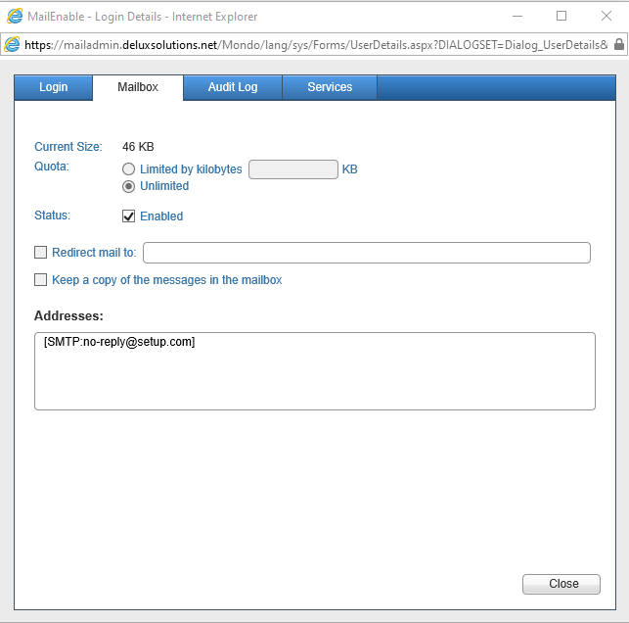
- Click on the Audit Log tab and you can view all emails that have been going through this account. This is useful if you are trying to manage spam etc.
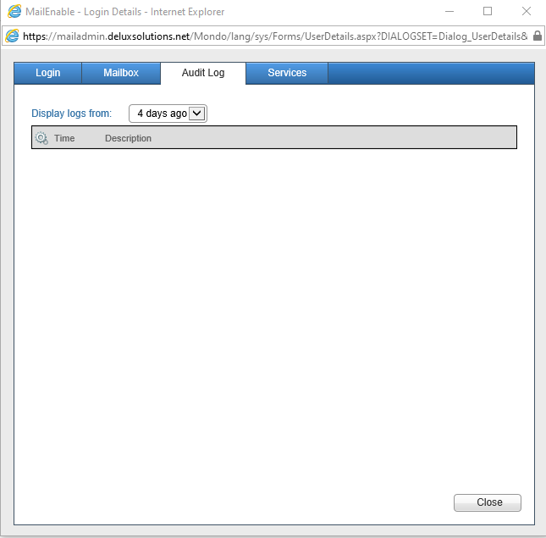

- Click on the Services tab and you can manage the services that you want this account to have access to. So for example if this was a no-reply email you want to send email from this address but not receive any emails. So you may want to set it up like below
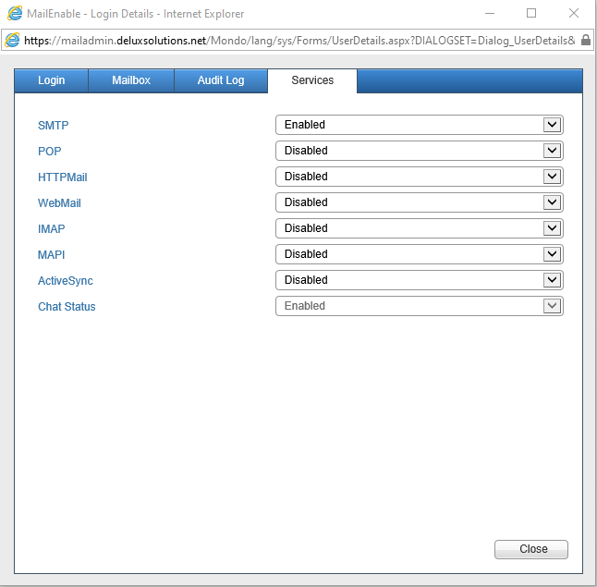

6.1.2 Creating A New Mailbox

- At the top of the center section click on Add New
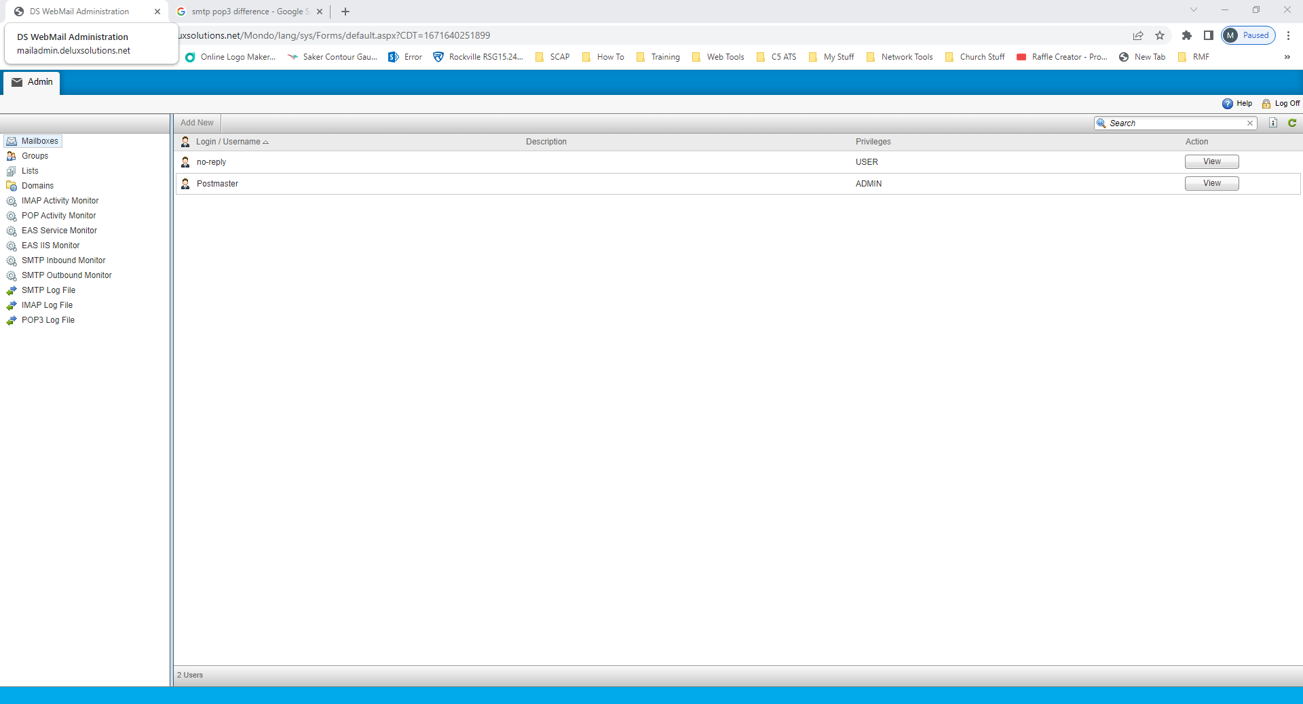

- The following window will open
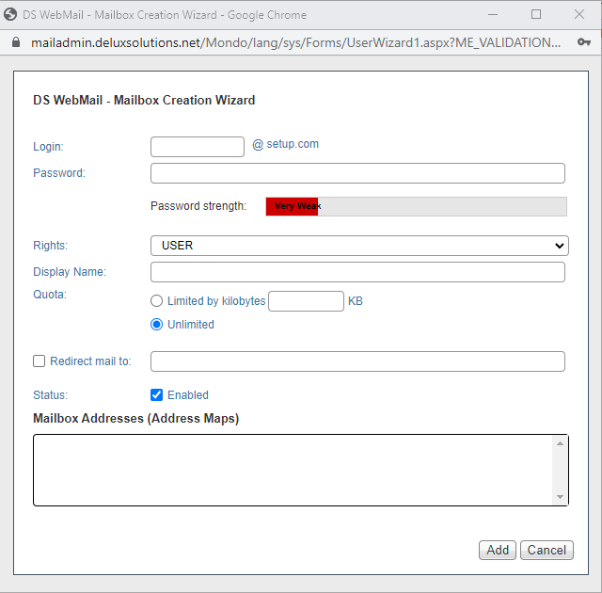
- Enter the name and the password for the email account (suggest firstname.lastname)
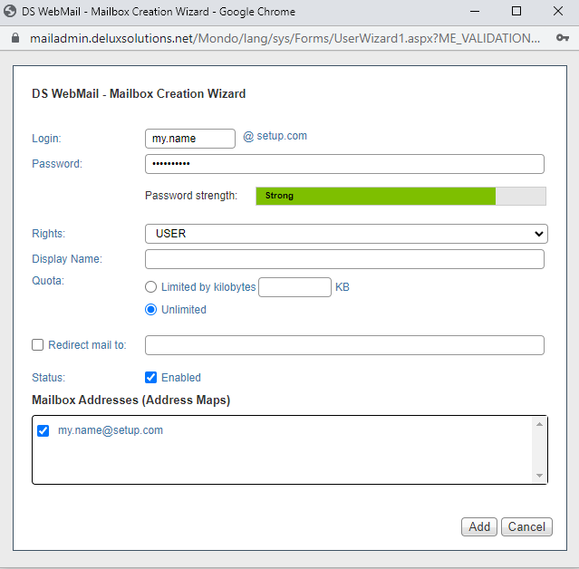

- Now from the Rights dropdown you can select if this user is a standard user or if you want them to be able to administer the email accounts
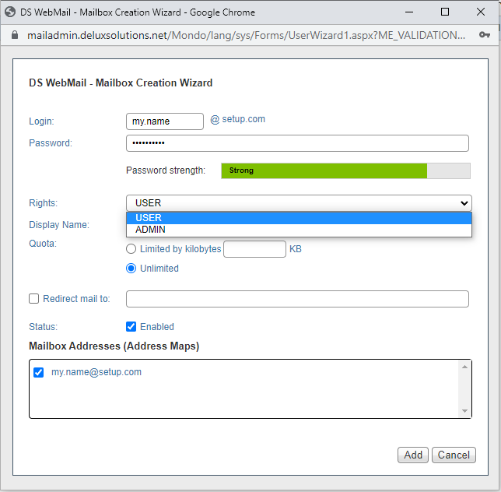
- Finally you have the option to set the display name, storage quota, redirect to another email address, and add additional email addresses
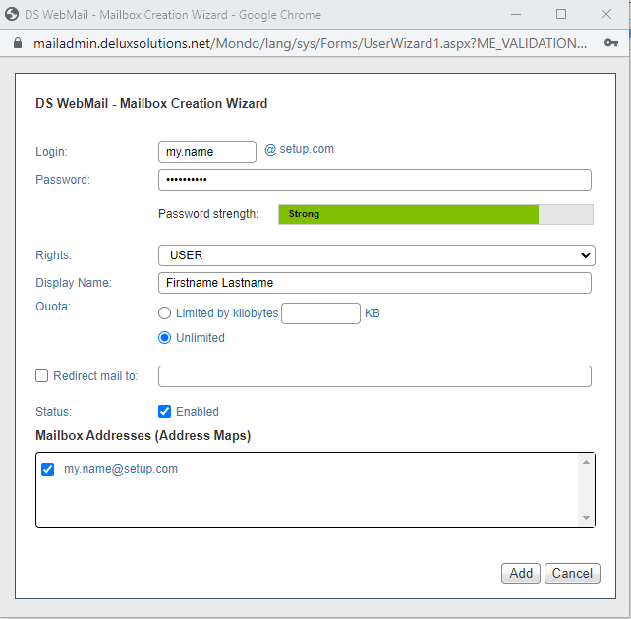

- When finished click Add and the new email will be in the list
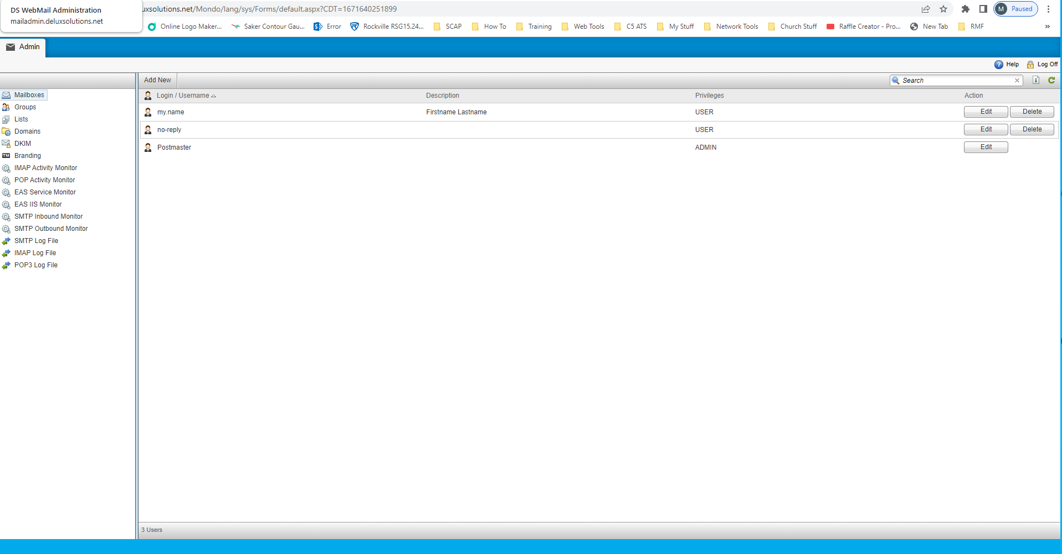

6.2 Groups
A group is an email address that maps multiple email addresses.
- In the left menu click on Groups
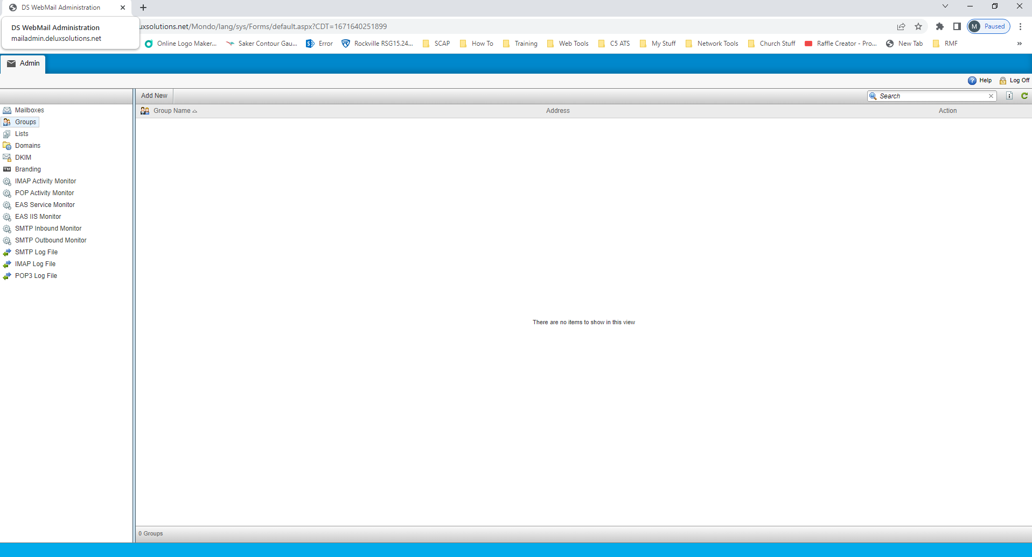

6.2.1 Creating A New Distribution Group

- At the top of the center section click on Add New and the following window will open
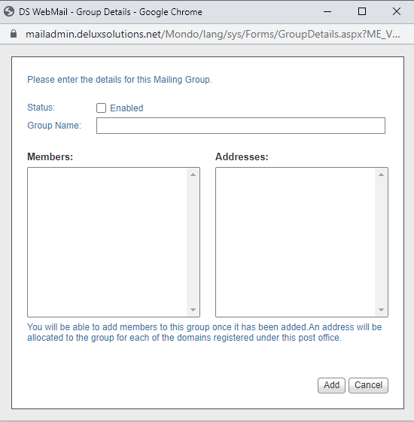
- Check the box to enable the group and then give it a name such as staff and then click Add
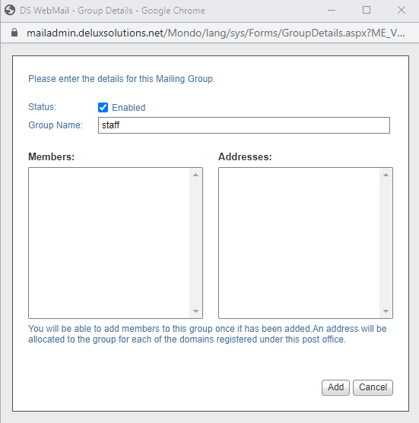

- Now the new group is in the list
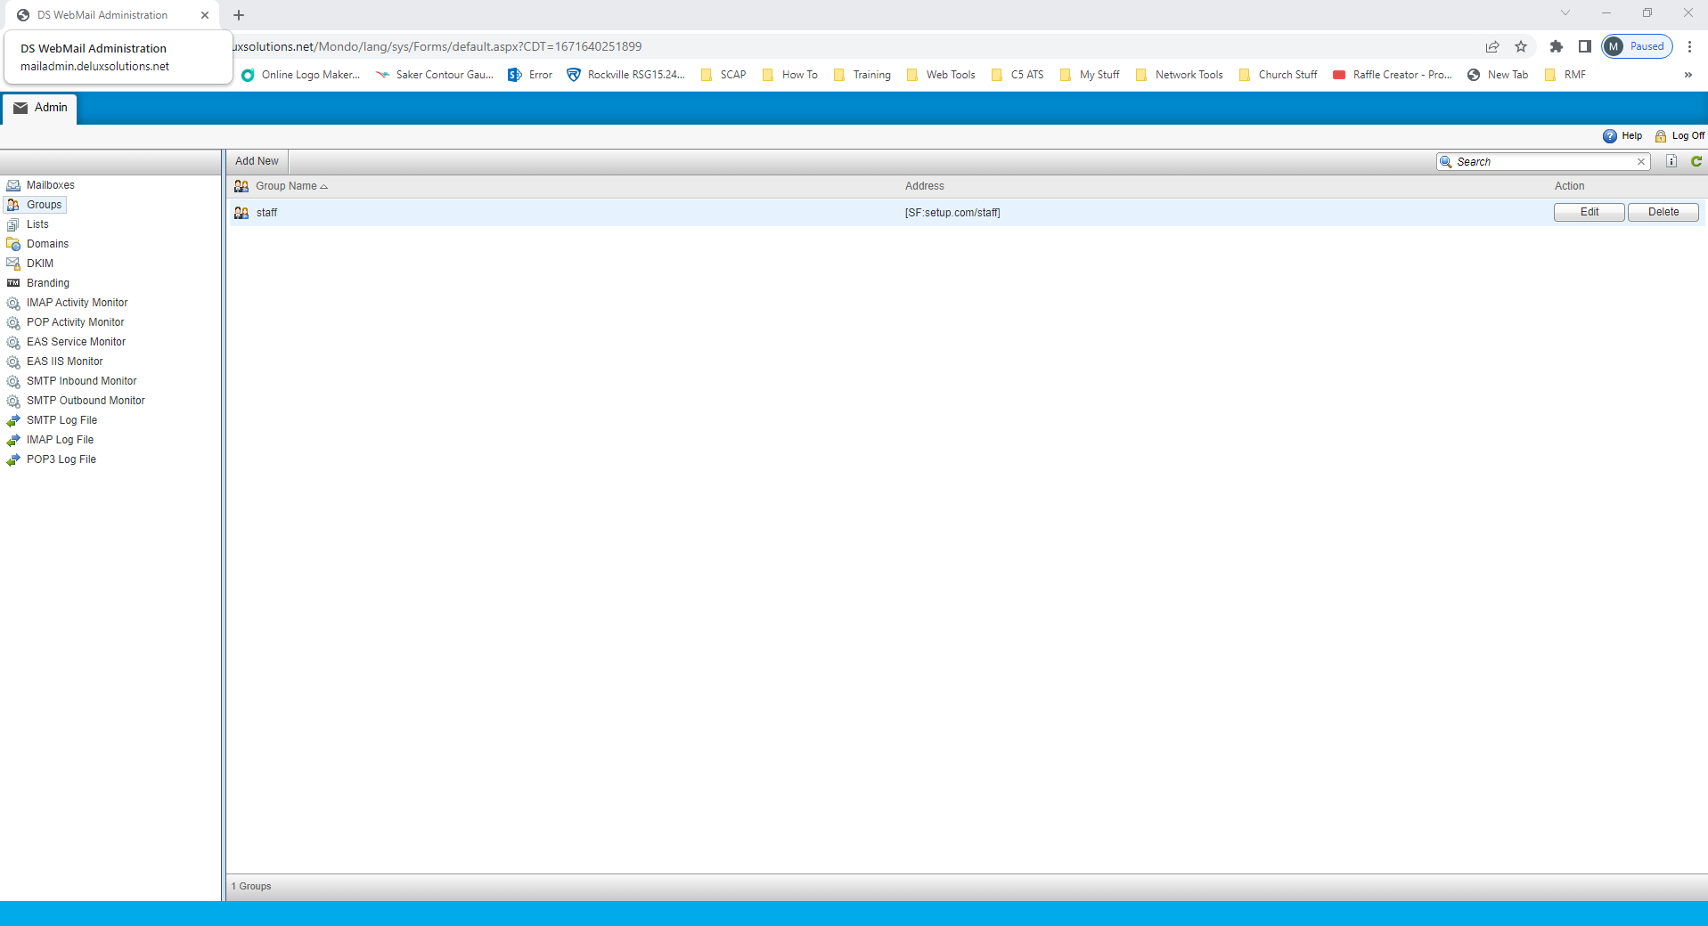

6.2.2 Modifying A Distribution Group

- The new group has been assigned an email address of groupname@domain.suffix. So in this example it would be staff@setup.com. Now on the far right of the list name click on Edit

- The following window will open and you can add members and additional email addresses
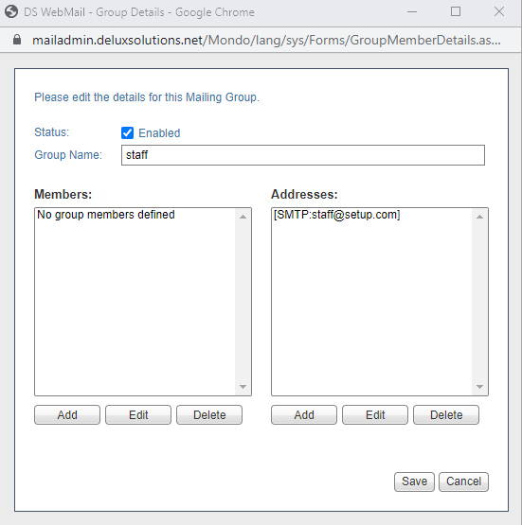
- Under Members click on Add and the following window opens
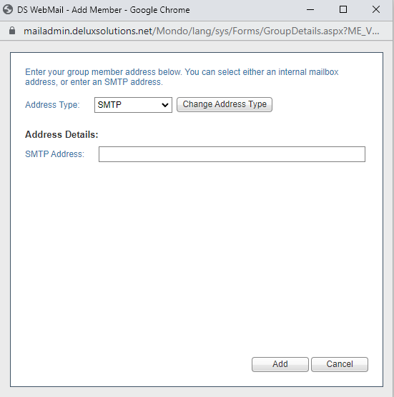

- By default the address type is set to SMTP which will allow you to add an external users email address. As this example is using staff from the dropdown select Local Postoffice
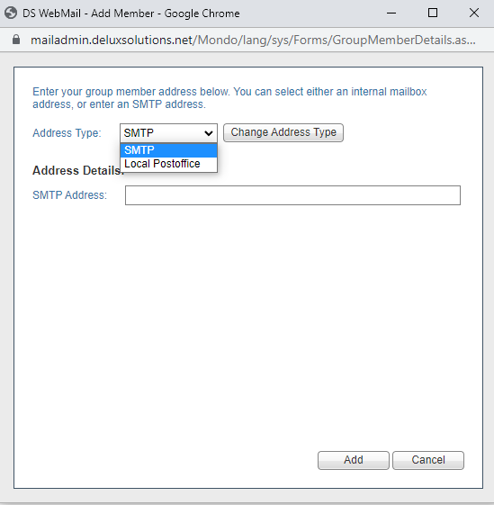
- Now from the mailbox dropdown you can select the user you want to add to the list.
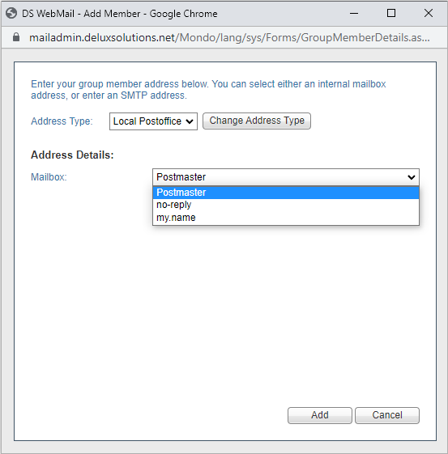

- In this example I will use my.name and then click Add and the user is now part of the group
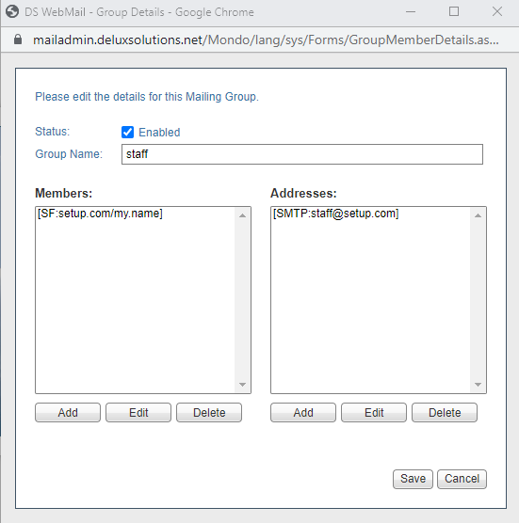

- Repeat these steps to add more users to the group

6.3 Lists
Mailing lists are used to create a mail-based forum where messages addressed to the list are published to its members.
- In the menu on the left click on Lists
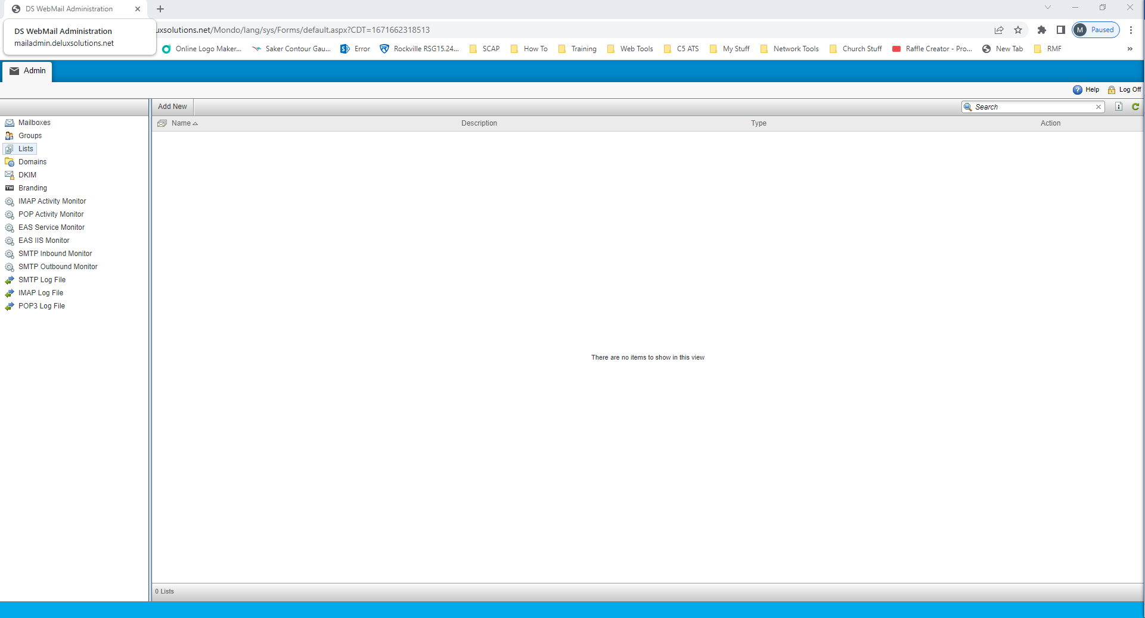

6.3.1 Creating A New List

- At the top of the center section click Add New and the following window will open
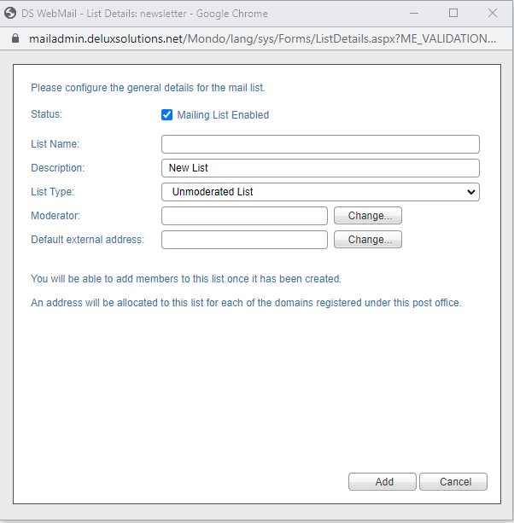
- Give the list a name and a description. For this example I am calling it cybersecurity
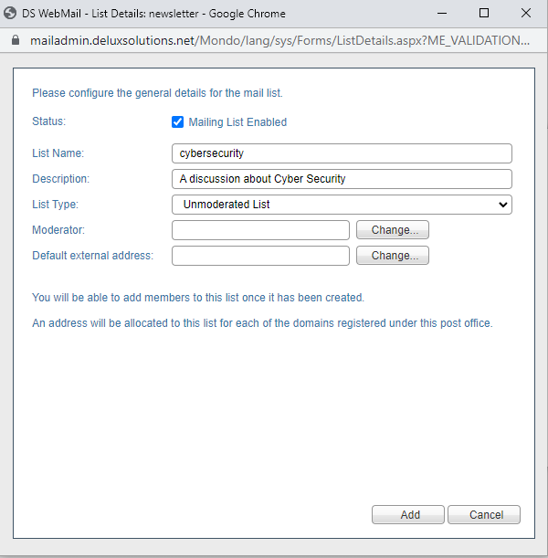

- Now from the List Type dropdown you have the option to select whether the list id moderated or unmoderated. Moderates means that the messages have to be approved before they go out to the members and that any new members have to be approved
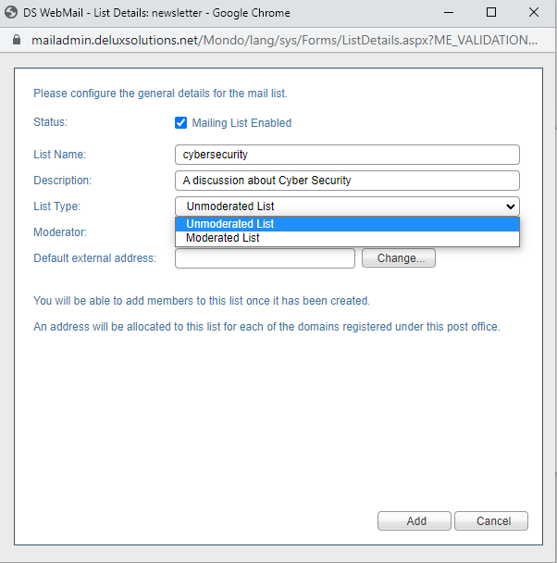
- For the purpose of this example I selected Moderated so now I have to set who the moderator is by clicking on Change
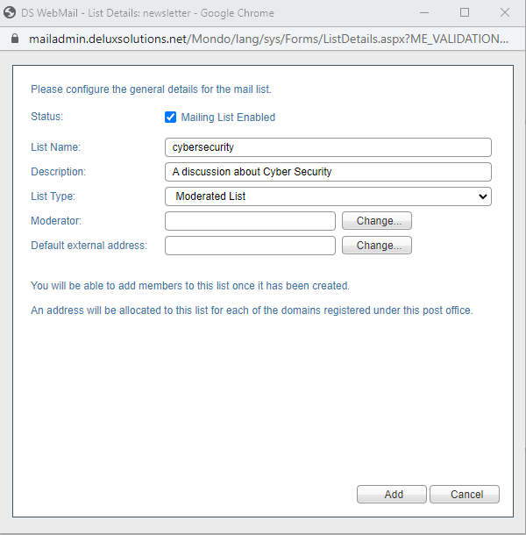

- The following window opens and I can enter the email name for the moderator. In this example I am using the my.name@setup.com and then click Change
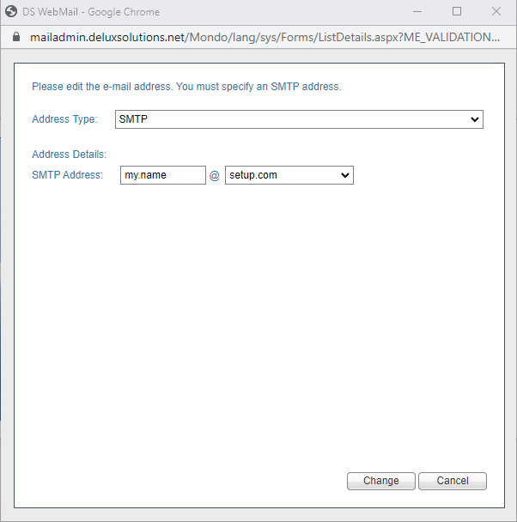
- Now I need to set the Default external address for the list so click Change
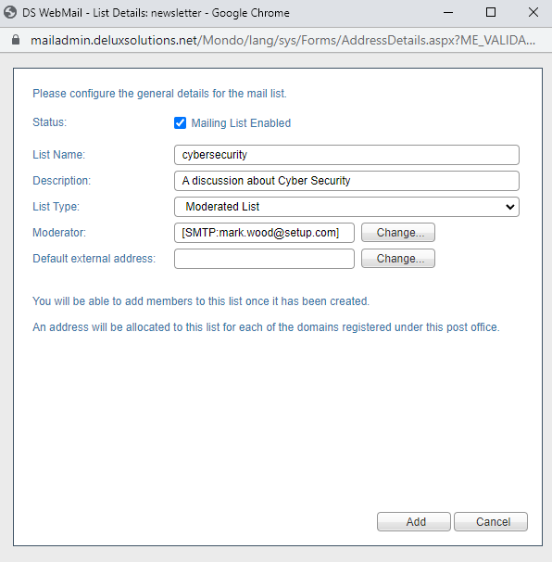

- As I used cybersecurity for the name of the list I am also using it as the SMTP address. Then click Change
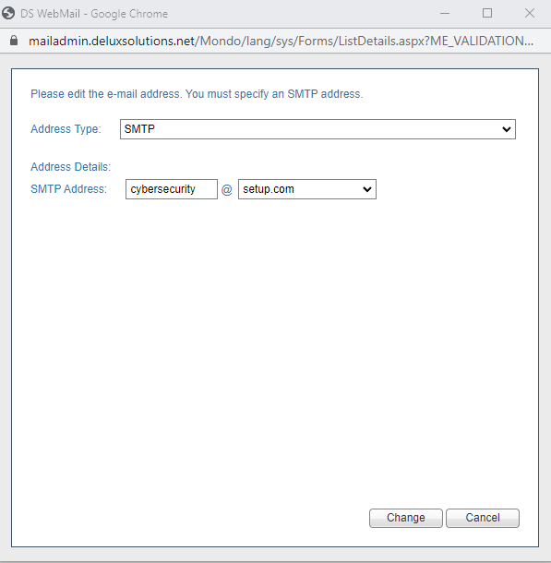
- Now click Add
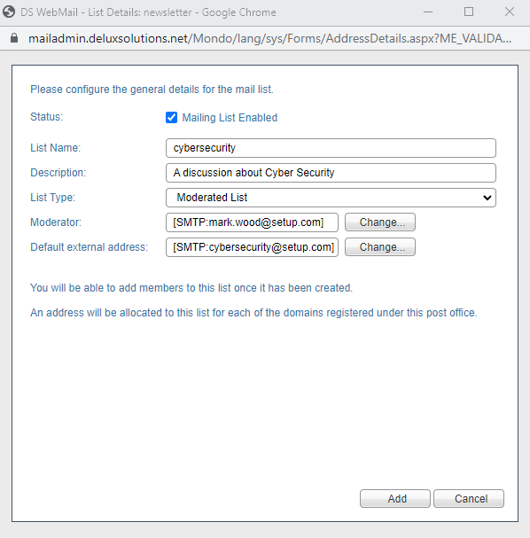

- You should now see the list in the center section
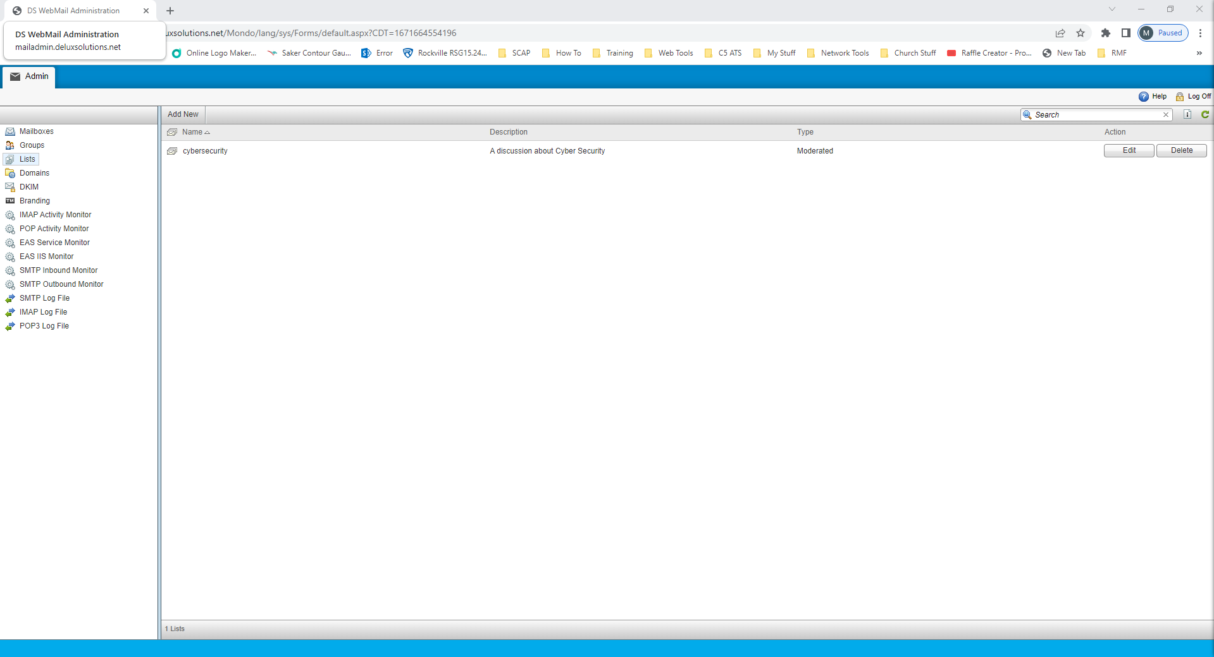

6.3.2 Modifying A List

- Now that the new list has been created click on Edit and the following screen opens
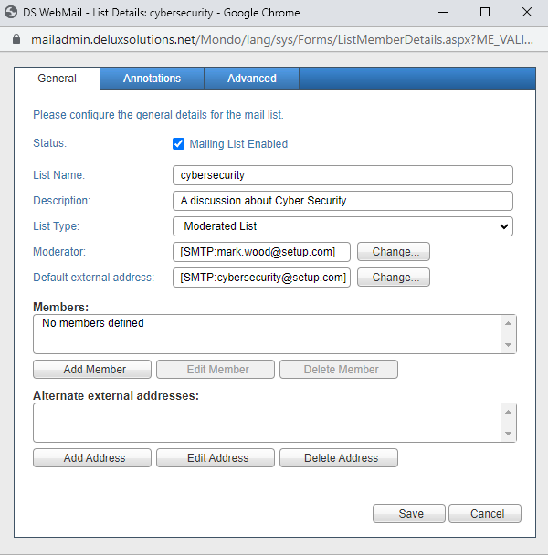

- The very first thing you need to do is add the moderator as a member of the list so click on Add Member and type in the email address and then click Add
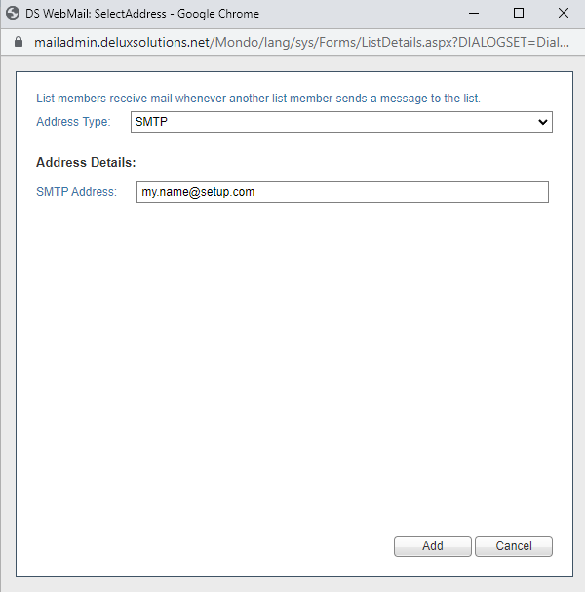
- Now you can repeat step 2 and add as many members as you want or you can send an email inviting people to join. Put a link in the email to subscribe to the list like <a href=mailto:cybersecurity@setup.com?subject=subscribe>Subscribe to our conversation on Cyber Security</a>
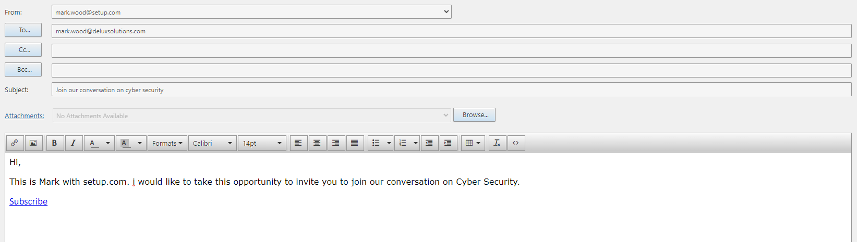

- When the user clicks the link in the email they are automatically joined to the list. This is a much easier method if you are adding multiple people to the list
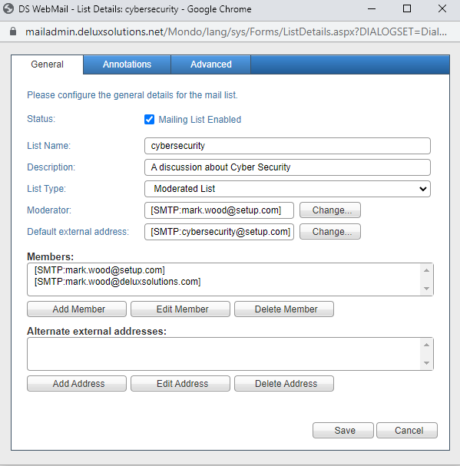
- Click on the Annotations tab and enter [ME_POSTOFFICE]: [ME_LIST] [ME_MEMBER_EMAIL] as the header and <a href=mailto:cybersecurity@setup.com?subject=unsubscribe>UnSubscribe</a> as the footer. Be sure to check the Enabled boxes
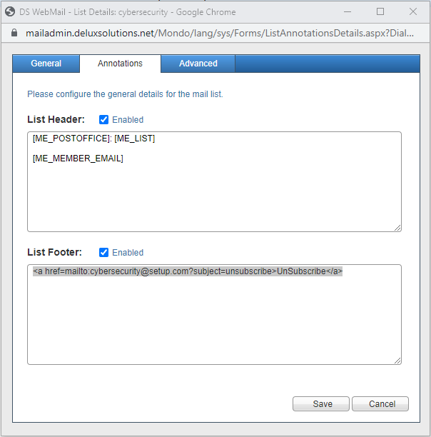

- Now click on the Advanced tab and set the settings according to the image below then click Save
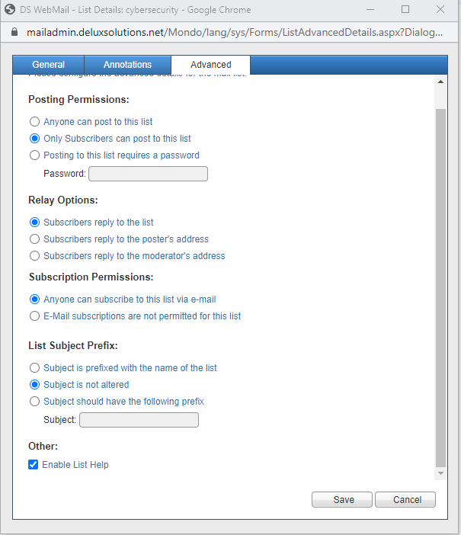

6.3.3 List Commands

- The following commands are available for the list by sending an email to the list (cybersecurity@setup.com)
- Help – sends an email back with the available commands of the list server
- Subscribe – adds the user to the list (if the list permissions allow them)
- Unsubscribe – removes the user from the list

- Some lists may be password protected. To post to these lists you must have been sent the password by the list owner or moderator.
You should send the password encapsulated between square braces and a colon in the subject line. Example: [:password:].

6.4 Domains
A domain is needed in order to create email addresses and allow users to send emails.
- In the menu on the left click on Domains. The domain we created when we set up your account will be listed
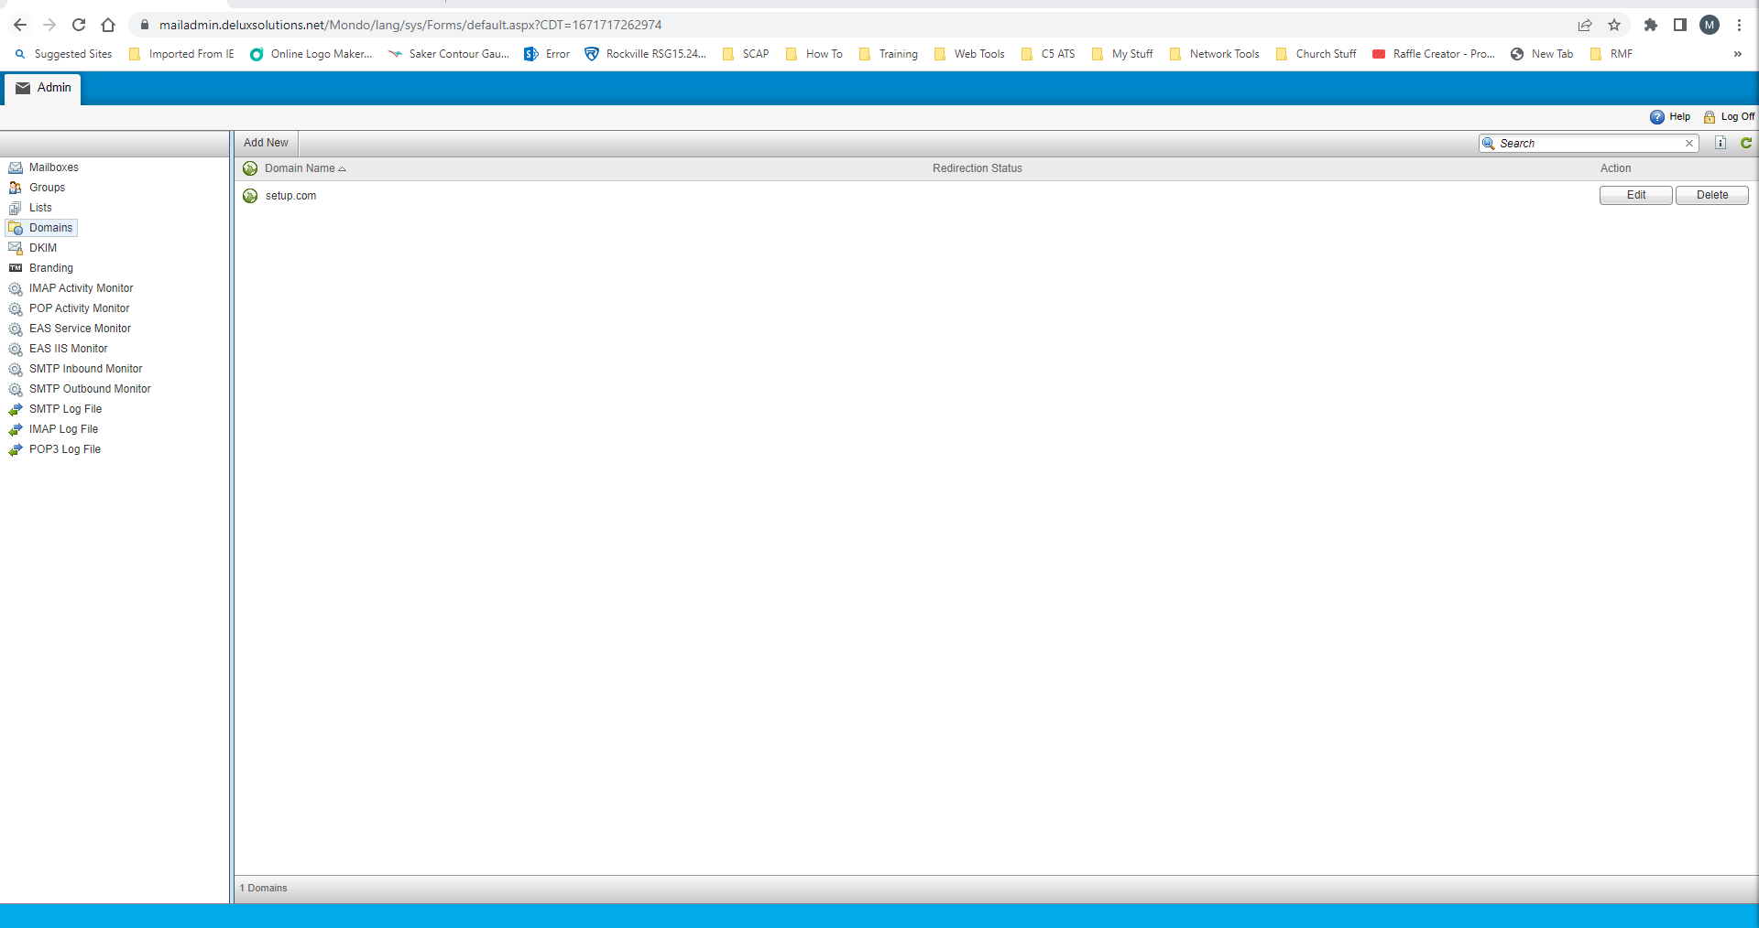

6.4.1 Creating A New Domain

- You may have purchased 2 domain names such as setup.com and setup.net. In some cases you may want your users to have email addresses to both or have the ability to choose as you create mailboxes. Click on Add New and the following window will open
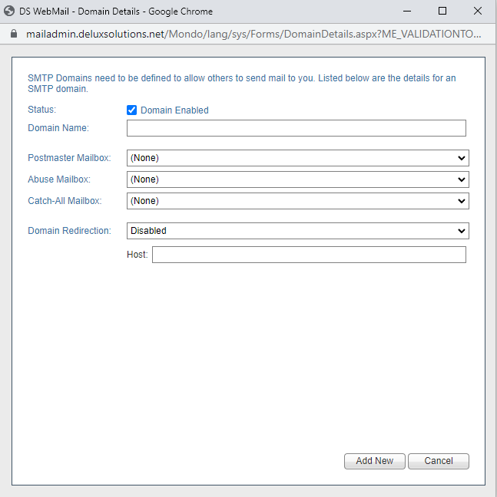

- Enter the domain name and select the postmaster mailbox from the dropdown then click Add New
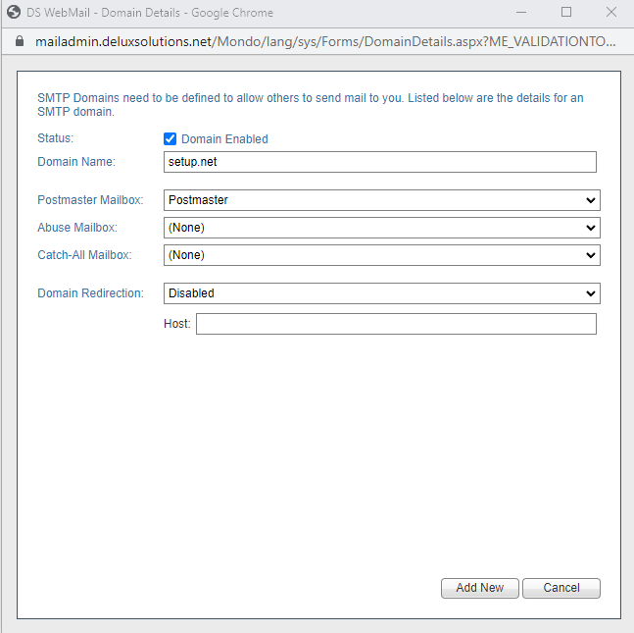

6.4.2 Modifying A Domain

- On the far right of a domain name click on edit
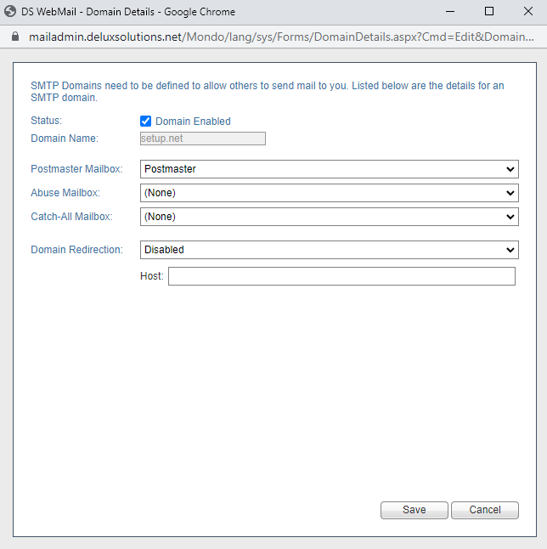

- Here you will have the options to select the Abuse and Catch-All mailboxes from the dropdowns. When done click Save
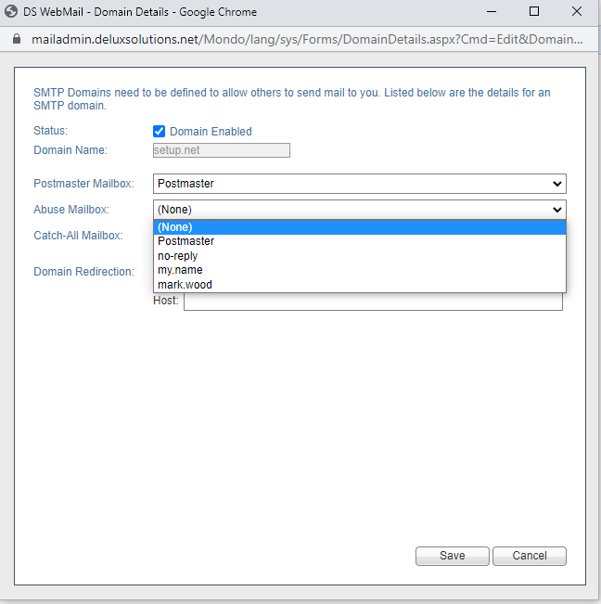

6.5 DKIM
DKIM provides a mechanism for verifying the integrity of a message.
- In the menu on the left click on DKIM
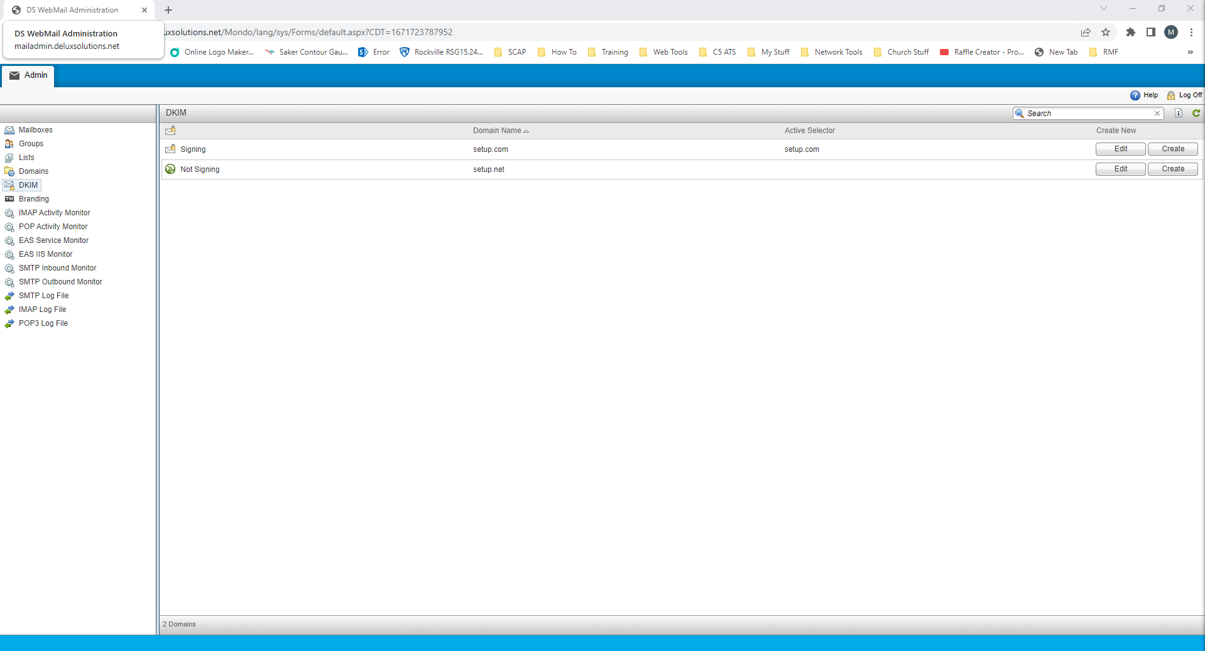

- This is something we set up for you when we created your post office and the DKIM record was added to your DNS. If you have added an additional domain to you post office and need a DKIM record for it just let us know by contacting info@deluxsolutions.com and we will take care of it for you

6.5.1 Modifying A DKIM Record

- On the far right of a domain click on Edit
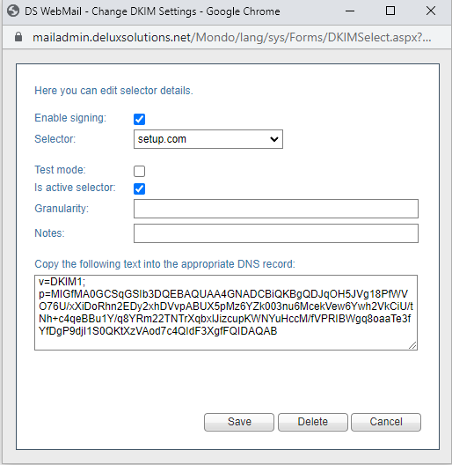
- Here you have the ability to place your DKIM record in test mode and disable it. I do not recommend making any changes here but you can copy the record and save it in a text file in case you make a mistake and need to put it back

NOTE: You can go through all of the other options on the left menu to monitor email activity and logs. Items like Branding are not currently available.

